
Federal
Aviation
Administration

Admin-PE-GEN PROCESS OF DMS PREAPPROVAL, ADMINISTRATIVE POST ACTIVITY REPORT AND OVERSIGHT ACTIVITIES
BUSINESS REQUIREMENTS DOCUMENT (BRD)
CONTRACT NO.

Author: GET.
Date: 7/10/2026
Version 1.0

Table of Contents
1 Introduction 1
1.1 Purpose 1
1.2 Scope of the document 1
2 Business Process Overview 1
2.1 Business Process 1
3 Use Case Description 2
3.1 DMS Preapproval 2
3.1.1 PreApproval Tab 4
3.1.2 Test/Check Tab: 5
3.1.3 Location Tab 7
3.1.4 Applicant/Application Tab 8
3.1.5 Documents/Comments Tab 9
3.1.6 Summary Tab 9
3.2 Post Activity Report 11
3.3 Oversight Activities 15
4 Appendices 19
4.1 Appendix A: Glossary 19
4.2 Appendix B: Abbreviations, Acronyms, and Definitions 19
4.3 Appendix C: Country List: 20
4.4 Appendix D: State List 25

List of Tables
Table 1.1-1: Stakeholders v
Table 2: Data Requirements – PreApproval Tab 4
Table 3: Data Requirements – Test/Check Tab 6
Table 4: Data Requirements – Location Tab 7
Table 5: Data Requirements – Applicant/Application Tab 8
Table 6: Data Requirements – Documents/Comments Tab 9
Table 7: Data Requirements – Post Activity Report (Test Information) 15
Table 8: Data Requirements – Oversight Activities 16
Table 9: Data Requirements – Oversight Activities (Unscheduled) 18
Table 10: Glossary 19
Table 11: Abbreviations, Acronyms, and Definitions 19

List of Figures
Figure 1: DMS Pre-Approval, Post Activity, and Oversight Process Flow Diagram 2
Figure 2: Action 2
Figure 3: Activity Links 3
Figure 4:Copy Pre-Approval 3
Figure 5: PreApproval 4
Figure 6: Test/Check (Top half of the page) 5
Figure 7: Test/Check (Bottom half of the page) 6
Figure 8: Location 7
Figure 9: Applicant/Application 8
Figure 10: Documents/Comments 9
Figure 11: Summary 11
Figure 12: Post Activity 12
Figure 13: Test Information 14
Figure 14: Oversight Activities 16
Figure 15: Oversight Activities (Unscheduled) 17

Revision History
Version Number | Date | Author | Justification
1.0 | 7/10/2026 | GET | BRD Initial Creation

Table 1.1-1: Stakeholders
Role | Name | Title | Email | Phone
Business PM
SME

Introduction

Purpose
This is a Business Requirements Document (BRD) that provides detailed requirements for AFS Group 2 Administrative Pilot Examiner with General Authorizations (Admin PE-GEN) Process of DMS Preapproval, Administrative Post Activity Report and Oversight Activities. The purpose of this document is to define detailed business specifications to serve as a reference for project teams and development teams for the detailed business requirements.

Scope of the document
Designee Management System (DMS) is a system for managing all aspects of the lifecycle of designees. The fundamental high-level common processes for all designee programs contain: Application Process, Selection & Evaluation, Appointment, Oversight & Management, and Termination & Suspension. This document addresses the Preapproval, Post Activity Report, and Oversight processes for the Admin-PE-GEN designee type in the DMS. The document will contain the end-to-end workflow modifications required for this administrative designee type.

Business Process Overview

Business Process
This section describes the overall business process. The more detailed requirements, data requirements, and diagrams for the Admin-PE-GEN Preapproval, Post Activity Reports, and Oversight processes will be part of the Use Case Descriptions sections of this document.
Preapproval, Post Activity, and Oversight Requirements:
The system will:
- Update the available Activity Links by removing “Create Practical Test/Proficiency Check Preapproval” and “Manage Make Model Series”.
- Allow the user to "Create Administrative Preapproval" via a six-tab process.
- Modify the Test/Check tab to display Admin-PE-GEN specific authorizations (Admin-PE-GEN-FPE, Admin-PE-GEN-MCE, Admin-PE-GEN-GIE, Admin-PE-GEN-FIRE, and Admin-PE-GEN-BAE) and restrict "Grade of Certificate sought" options.
- Remove non-applicable fields such as “Make/Model/Series sought” and “Multiple Applicants?” from Preapprovals and Post Activity Reports.
- Modify the Oversight Activities tab by removing non-applicable observations and inspections (e.g., “Direct Observation Ground”, “Direct Observation Flight”, “Testing Proficiency Check”).
- Allow the user to replicate a historically submitted or expired preapproval record using a "Copy" function, cloning historical data entries into a new draft instance to reduce redundant manual text entries.
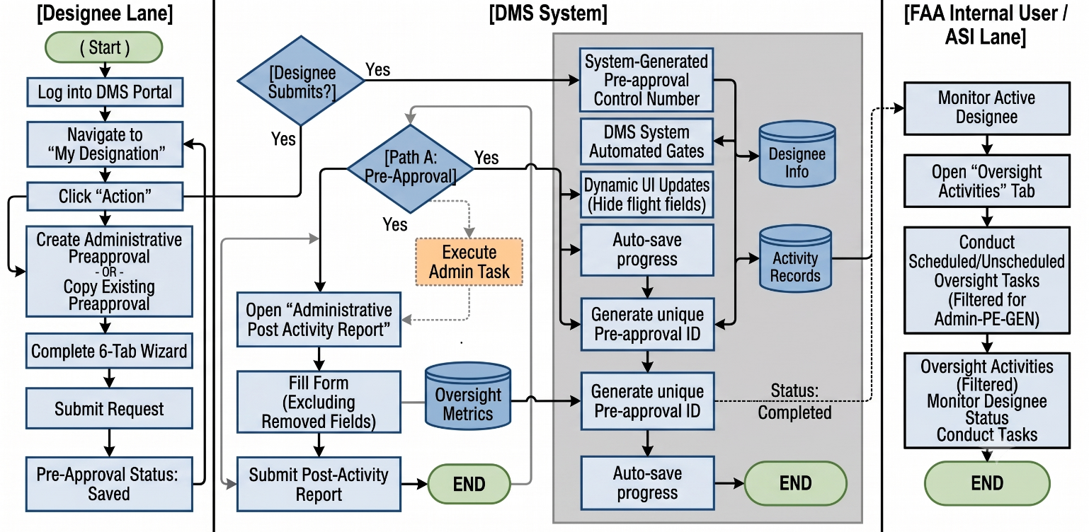
Figure 1: DMS Pre-Approval, Post Activity, and Oversight Process Flow Diagram

Use Case Description
This section describes requirements specifications for the Admin-PE-GEN Preapproval, Post Activity and Oversight Process.

DMS Preapproval
The DMS Preapproval workflow for the Admin-PE-GEN designee type shall be established using the current DPE Process for Administrative Preapproval as the baseline, with the following system modifications.
Action: When a user navigates to the "My Designation(s)" section on the designee's DMS home page and selects "Action", the system should update the available Activity Links as follows:
Figure 2: Action
Form & Navigation Modifications:
- Remove Link: "Create Practical Test/Proficiency Check Preapproval"
- Remove Link: "Manage Make Model Series"
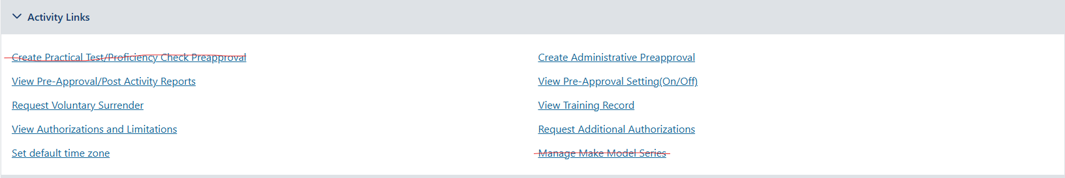
Updated below Screenshot
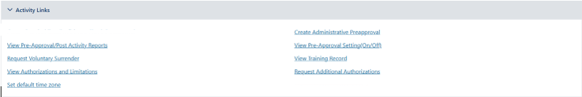
Figure 3: Activity Links

- Retain Link: "Create Administrative Preapproval"
Selecting Create Administrative Preapproval drops the designee into a standardized wizard across six functional layout tabs.
- Add Feature: "Copy Existing Preapproval"
The designee can copy an existing pre-approval by going to the Summary tab and clicking the ‘Copy’ button.
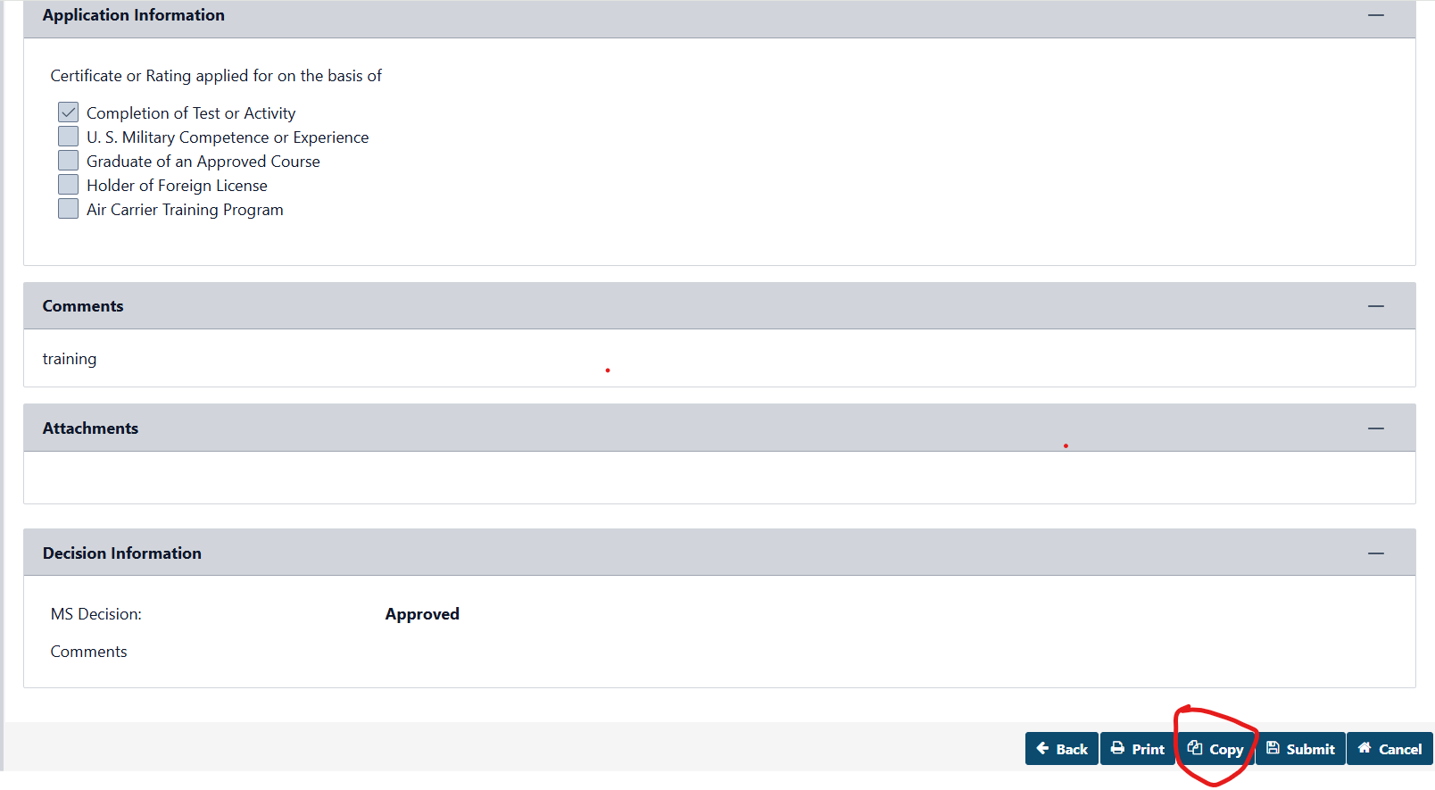
Figure 4:Copy Pre-Approval

PreApproval Tab
The first tab displays static context cards mapping user status records. The system retains legacy DPE information extraction loops with zero variations.
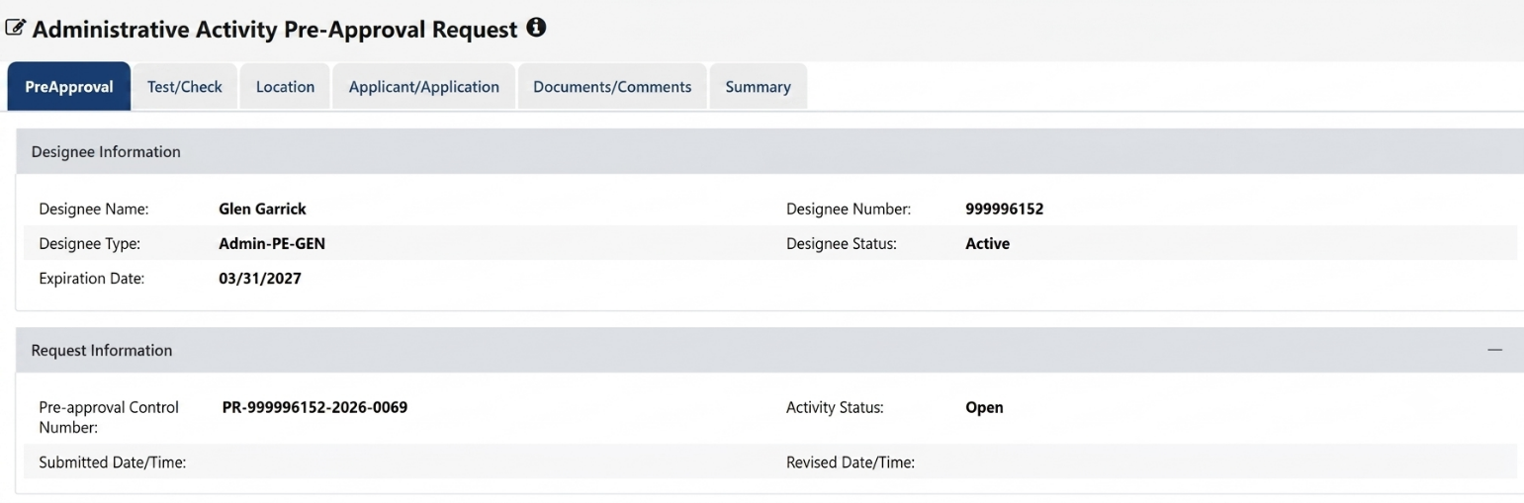
Figure 5: PreApproval

Table 2: Data Requirements – PreApproval Tab
Attribute Name | Field Type | Required (Y/N) | Format/Function | Error Message When Required
Designee Information | Header | N/A
Designee Name | Read-Only Text | N/A | Pulls full text name from profile registry.
Designee Number | Read-Only Text | N/A | Unique identifier alphanumeric output format.
Designee Type | Read-Only Text | N/A | Hardcoded display: Admin-PE-GEN
Designee Status | Read-Only Text | N/A | Reflects current designee system status.
Request Information | Header | N/A
Expiration Date | Read-Only Text | N/A | Maps current expiration tracking field
Pre-approval Control Number | Read-Only Text | N/A | Automatically generated unique system sequence matching the format: PR-[Designee Number]-[Year]-[4-Digit Sequential Number] (e.g., PR-999996152-2026-0069)
Activity Status | Read-Only Text | N/A | Initial unsubmitted state renders as "Saved".

Test/Check Tab:
The system shall modify the top and bottom halves of the form page according to the Data Requirements Table below.

2nd Tab – “Test/Check”: Top half of the page
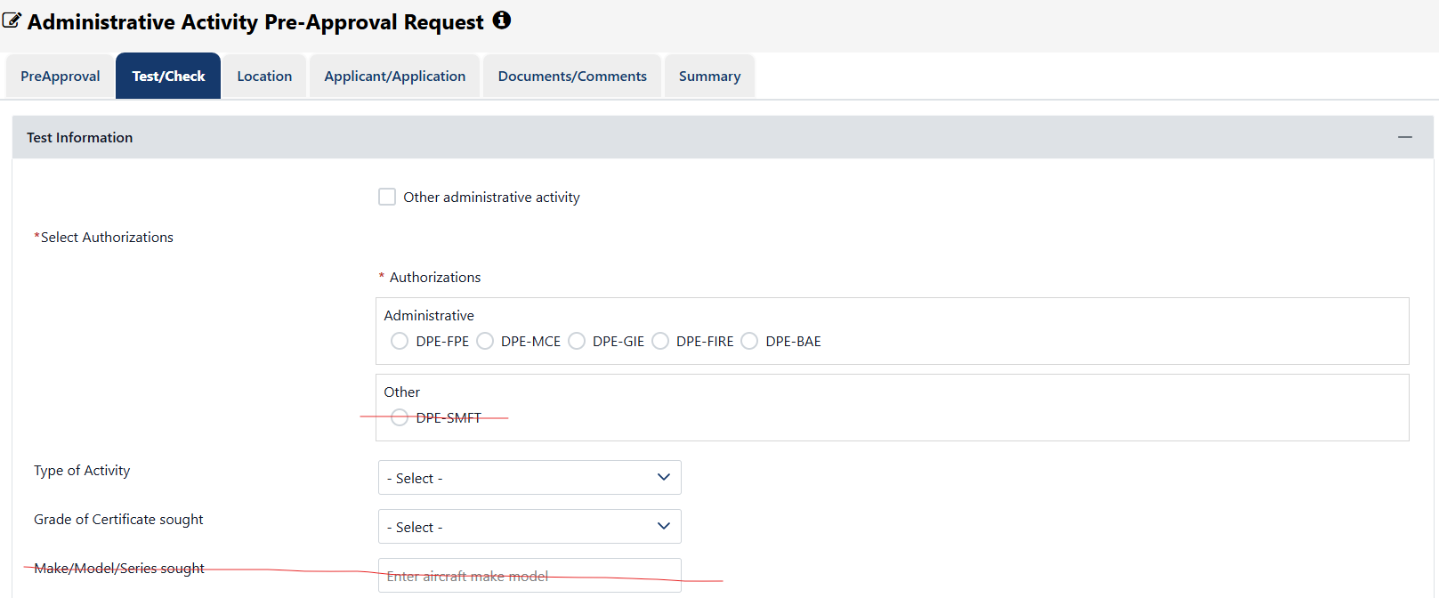
Figure 6: Test/Check (Top half of the page)

Authorizations: The system shall display the following new authorization options: Admin-PE-GEN-FPE, Admin-PE-GEN-MCE, Admin-PE-GEN-GIE, Admin-PE-GEN-FIRE, and Admin-PE-GEN-BAE. The system shall remove the "Other" option.
Type of Activity: The system shall retain existing options (Original Grade Pilot Certificate, Additional Rating, Original Issuance of CFI, Renewal of CFI).
Grade of Certificate sought: The system shall restrict options to the following: Private Pilot, Commercial Pilot, Airline Transport Pilot, Flight Instructor, Remote Pilot, Ground Instructor, N/A, and Instrument Rating.
Make/Model/Series sought: The system shall remove this field.

2nd Tab – “Test/Check”: Bottom half of the page
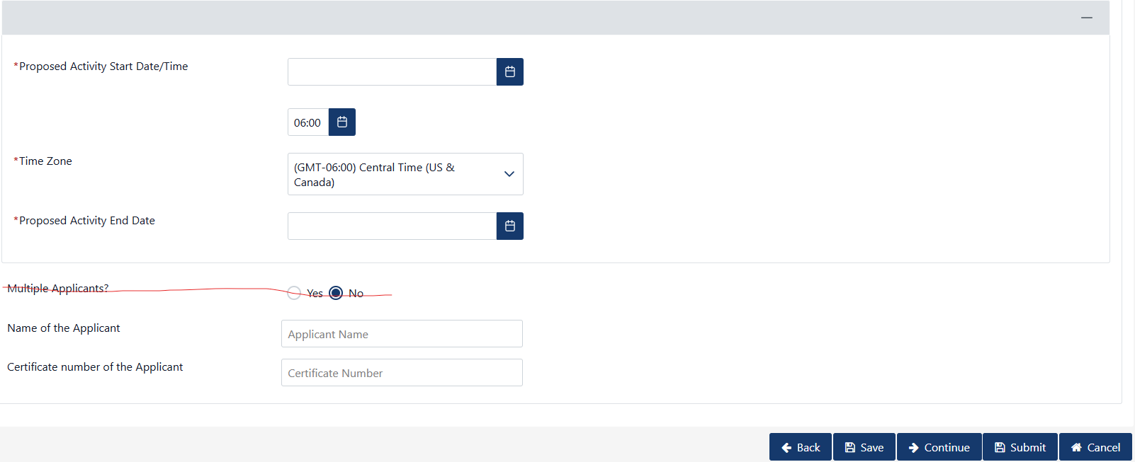
Figure 7: Test/Check (Bottom half of the page)

“Proposed Activity Start Date/Time”: No Change
“Time Zone”: No Change
“Proposed Activity End Date”: No Change
“Multiple Applicants?”: Remove
“Name of the Applicant”: No Change
“Certificate number of the Applicant”: No Change

Table 3: Data Requirements – Test/Check Tab

Attribute Name | Field Type | Required (Y/N) | Format/Function | Error Message When Required
Select Authorizations | Section Header | N/A | Group container for selection block. | N/A
Administrative Codes | Checkbox Group | Yes | Array components: Admin-PE-GEN-FPE, MCE, GIE, FIRE, BAE. Multi-select permitted. | An authorization type must be selected.
Type of Activity | Dropdown | Yes | Retains: Original Grade Pilot Certificate, Additional Rating, Original Issuance of CFI, Renewal of CFI. | Activity selection is required.
Grade of Certificate sought | Dropdown | Yes | Restricted option mapping index. | Certificate grade value is required.
Proposed Activity Start Date/Time | Date/Time Picker | Yes | Calendar integration with continuous verification loops. | Start date/time is required.
Time Zone | Dropdown | Yes | System default localization drop selection index. | Time zone selection is required.
Proposed Activity End Date | Date Picker | Yes | Standard constraint boundary verification calendar interface. | End date is required.
Name of the Applicant | Text Input | No | Full character string representation field. | N/A
Certificate number of the Applicant | Text Input | No | Validates format characters against reference standards. | N/A

Location Tab
3rd Tab – “Location”: The system shall retain the existing DPE functionality with no changes.
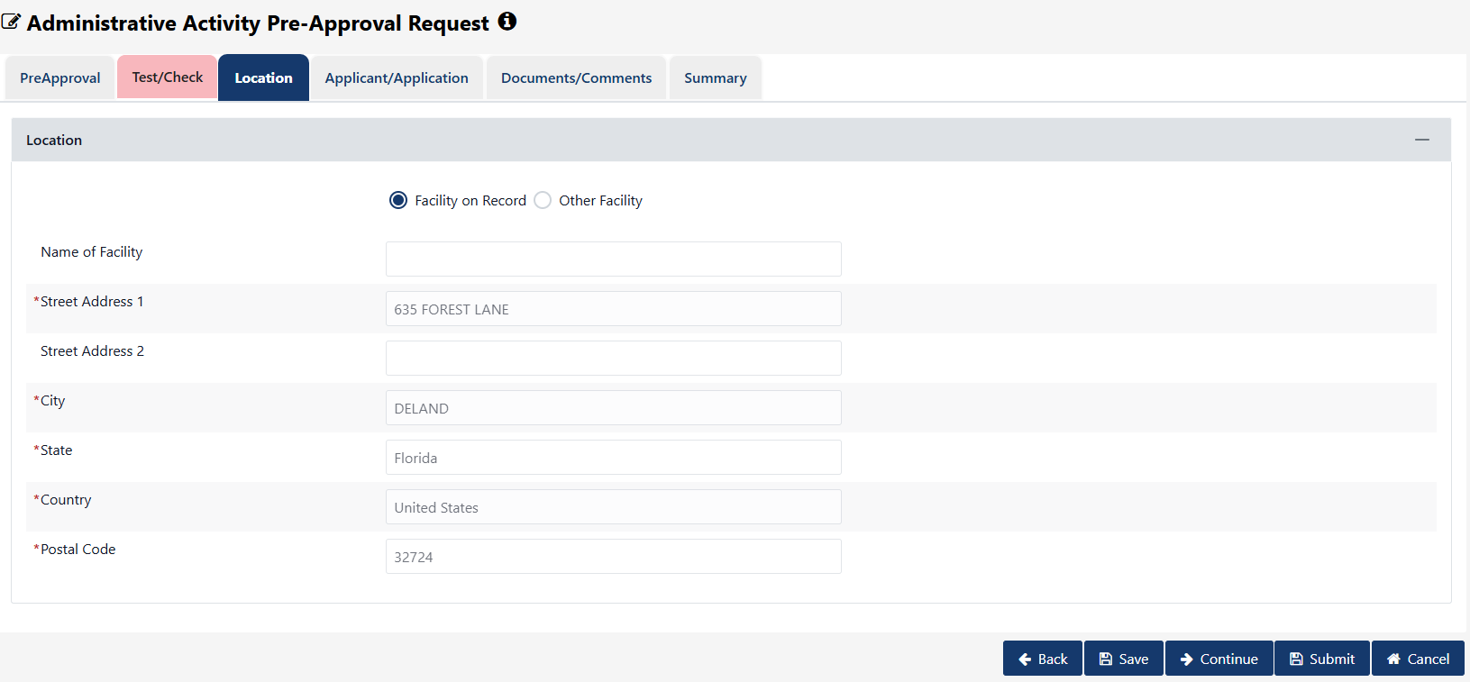
Figure 8: Location

Table 4: Data Requirements – Location Tab
Attribute Name | Field Type | Required (Y/N) | Format/Function | Error Message When Required
Facility Type Selector | Radio Buttons | Yes | Options: Facility on Record or Other Facility. | N/A
Name of Facility | Text Input | Yes | Character tracking text block descriptor. | Facility name text required.
Street Address 1 | Text Input | Yes | Physical location reference mapping string. | Street address value is required.
Street Address 2 | Text Input | No | Secondary alphanumeric location extensions. | N/A
City | Text Input | Yes | Standard spelling geography string value. | City identifier is required.
State | Dropdown | Conditional | Standard list index. Hidden if country field value is non-USA. | State entry is required.
Country | Dropdown | Yes | Defaults directly to United States. | Country selection is required.
Postal Code | Text Input | Yes | Evaluates formatting constraints based on country choice. | Postal parsing code required.

Applicant/Application Tab
4th Tab – “Applicant/Application”: The system shall retain the existing DPE functionality with no changes.
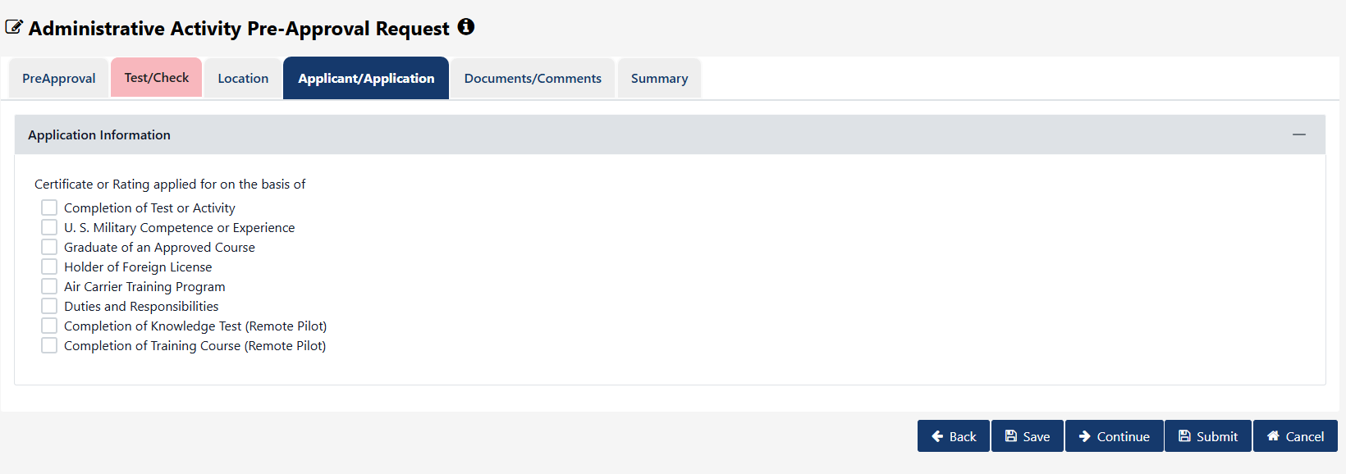
Figure 9: Applicant/Application

Table 5: Data Requirements – Applicant/Application Tab
Attribute Name | Field Type | Required (Y/N) | Format/Function | Error Message When Required
Certificate or Rating applied for on the basis of | Checkbox Group | Yes | Options: Completion of Test/Activity, U.S. Military Competence/Experience, Graduate of Approved Course, Holder of Foreign License, Air Carrier Training Program, Duties and Responsibilities, Completion of Knowledge Test (Remote Pilot), Completion of Training Course (Remote Pilot). | Selection of a processing rationale is required.

Documents/Comments Tab
5th Tab – “Documents/Comments”: The system shall retain the existing DPE functionality with no changes.
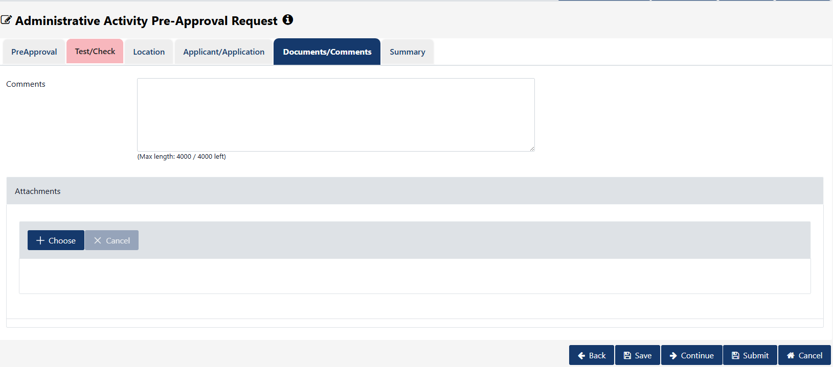
Figure 10: Documents/Comments

Table 6: Data Requirements – Documents/Comments Tab
Attribute Name | Field Type | Required (Y/N) | Format/Function | Error Message When Required
Comments | Text Area | No | Maximum length bounding index limit of 4000 characters. | N/A
Attachments Component | File Upload | No | Integrated dynamic validation checks during file streaming. | N/A

Summary Tab
6th Tab – “Summary”: The system shall display a read-only summary page reflecting all updated data fields and removals established in the previous tabs.
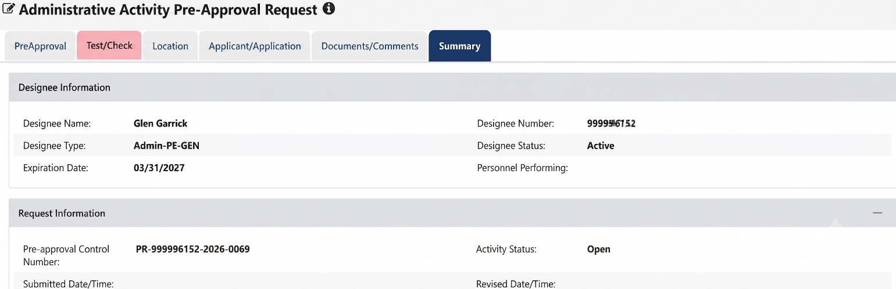

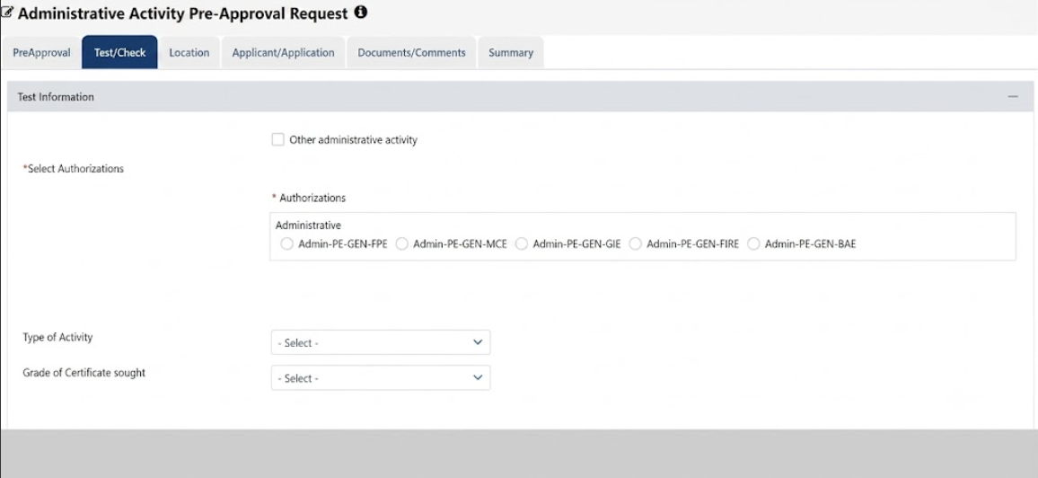
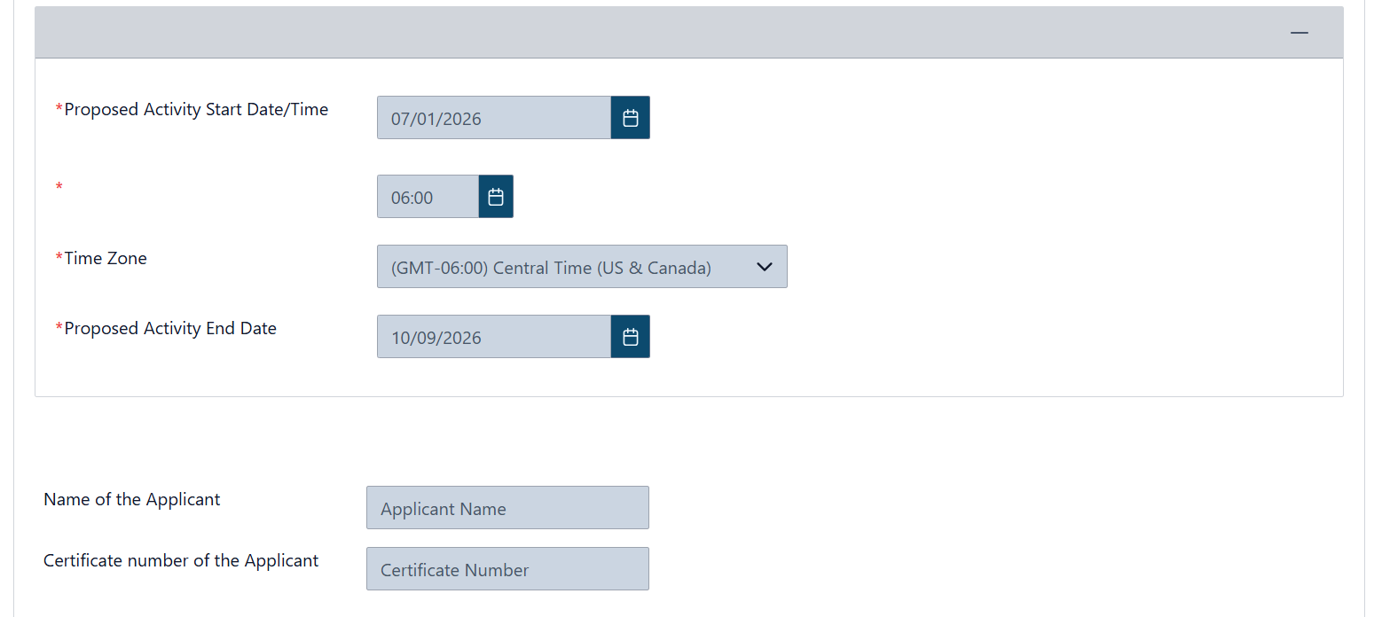
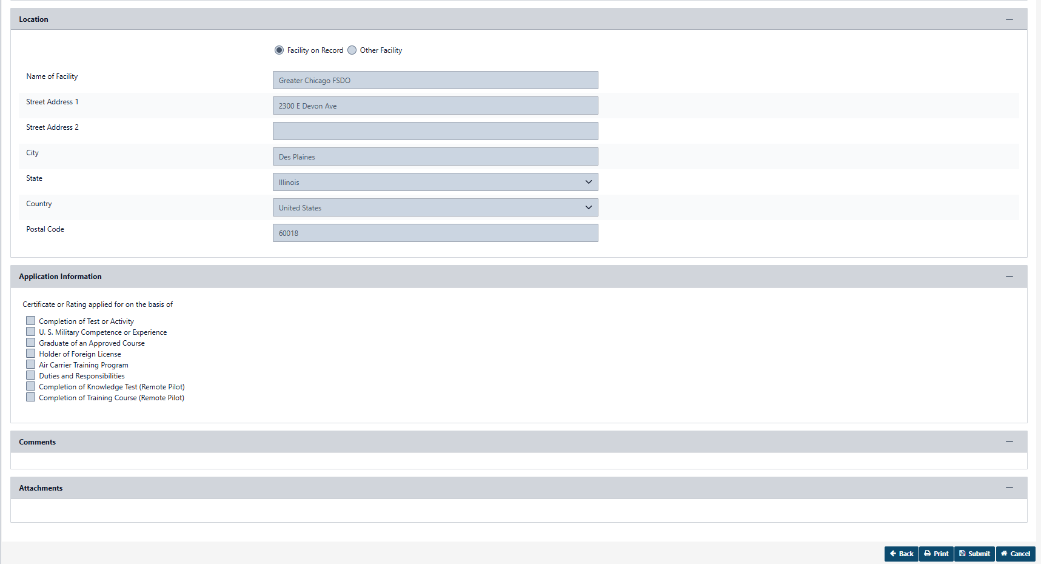

Figure 11: Summary

Post Activity Report
The DMS Post Activity workflow for the new Admin-PE-GEN designee type shall utilize the existing Administrative Post Activity Report established in the current DPE Process.
Administrative Post Activity Report – From DPE Process
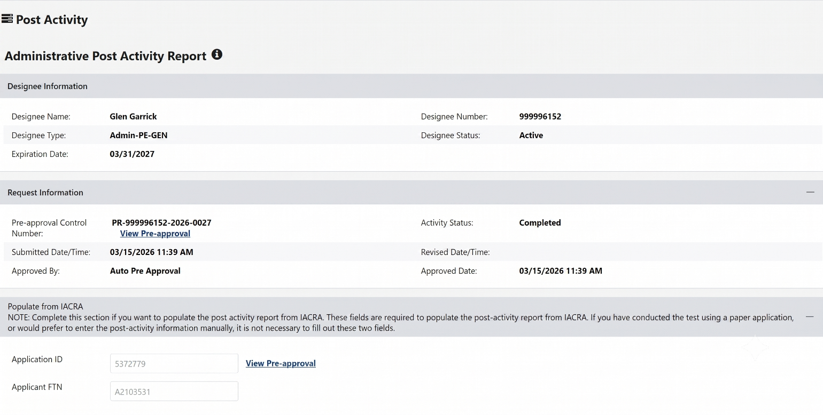
Figure 12: Post Activity

Test Information Section:
When the user accesses the Administrative Post Activity Report, the system shall modify the Test Information Section by explicitly removing the following fields:
- "Other administrative activity"
- "Other"
- "Make/Model/Series sought"
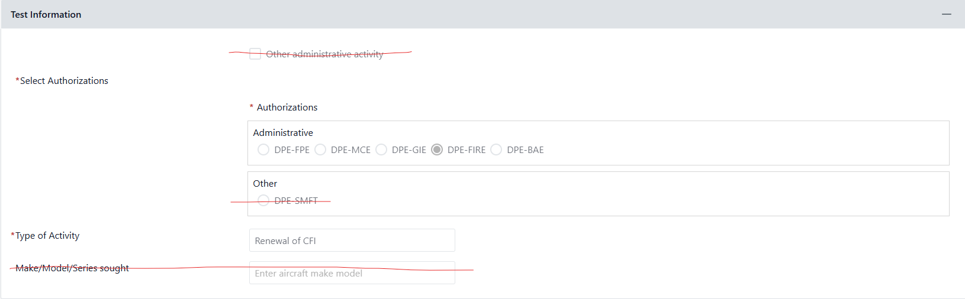

Updated below Screenshot

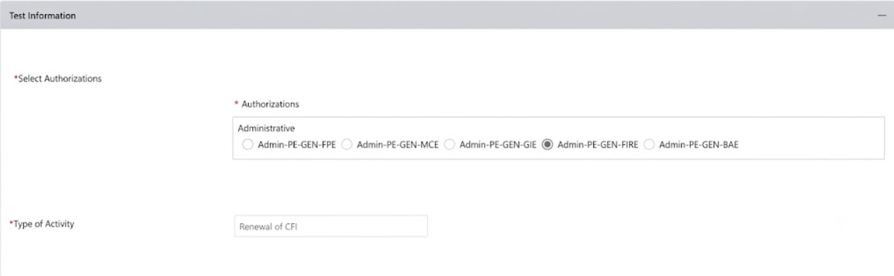

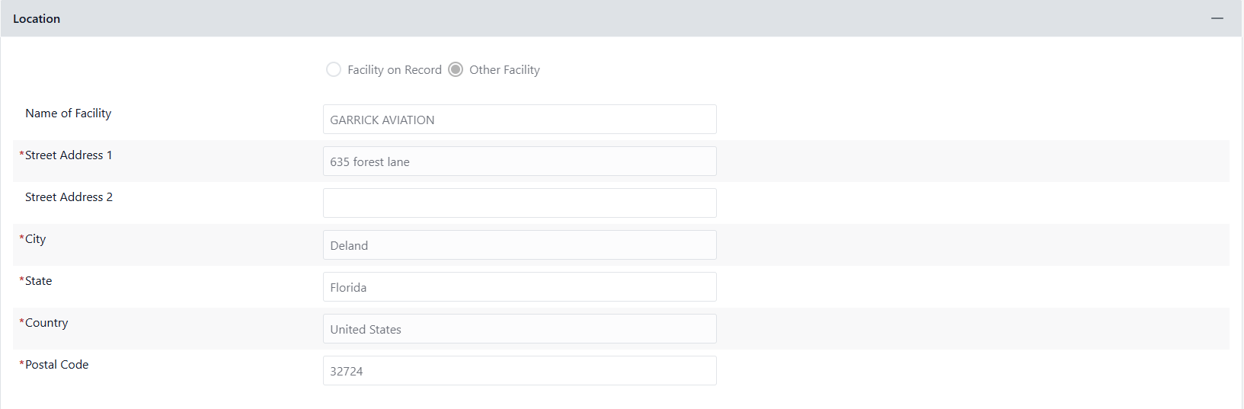
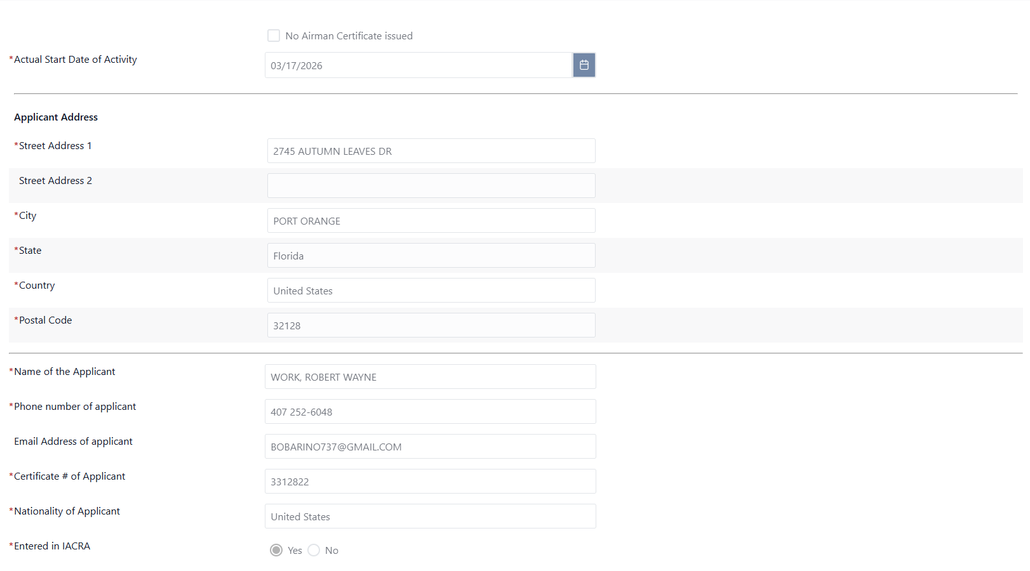

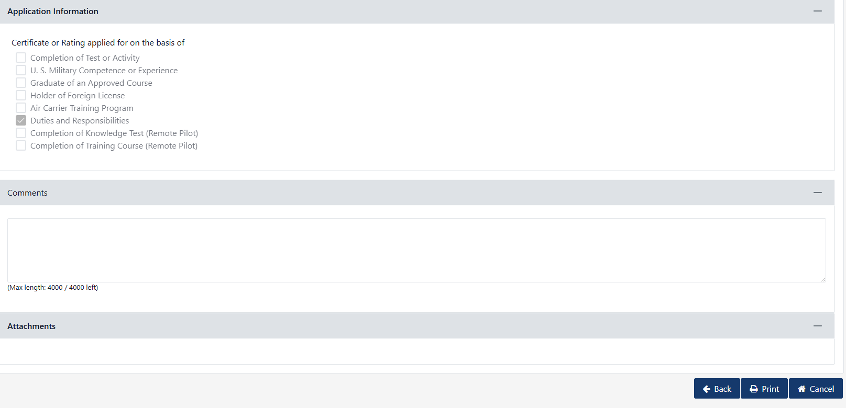
Figure 13: Test Information

Structural Form Removals:
- Remove Checkbox Block: "Other administrative activity"
- Remove Checkbox Row Element: "Other"
- Remove Input Field Content Area: "Make/Model/Series sought"
- The dynamic framework automatically adapts, arranging active options cleanly across authorization fields.

Table 7: Data Requirements – Post Activity Report (Test Information)
Attribute Name | Field Type | Required (Y/N) | Format/Function | Error Message When Required
Select Authorizations | Section Header | N/A | Demarcates active block boundaries. | N/A
Administrative Options | Radio Button Array | Yes | Options map: Admin-PE-GEN-FPE, Admin-PE-GEN-MCE, Admin-PE-GEN-GIE, Admin-PE-GEN-FIRE, Admin-PE-GEN-BAE. Selection matrix dynamically defaults to matching item preapproved inside parent records. | Authorization confirmation is required.
Type of Activity | Read-Only Text | N/A | Pulled directly from preapproval reference profiles. | N/A
Actual Start Date of Activity | Date Picker | Yes | Standard validation check routine loops. | Verification date is required.
Applicant Address String blocks | Text Matrix | Yes | Field grouping: Street 1, City, State, Country, Postal Code. | Address tracking records are required.
Name of the Applicant | Text Input | Yes | Last Name, First Name system character structure format. | Applicant reference identification required.
Phone number of applicant | Text Input | Yes | Digit character validation filtering. | Applicant contact path required.
Email Address of applicant | Text Input | Yes | Standard string configuration pattern matching. | Contact address string required.
Certificate # of Applicant | Text Input | Yes | Character registration validation mapping lookups. | Registration number track required.
Nationality of Applicant | Dropdown | Yes | Pulls reference names matching active geopolitical tables. | Country values registration required.
Entered in IACRA | Radio Control | Yes | Choices: Yes or No. | Selection of processing index required.

Oversight Activities
Proposed DMS Oversight for new designee type (Admin-PE-GEN):
From existing DPE “Oversight Activities” tab in DMS (Top Half of Page)
- Remove “Direct Observation Ground”, Direct Observation Flight”, and “Plan of Action”
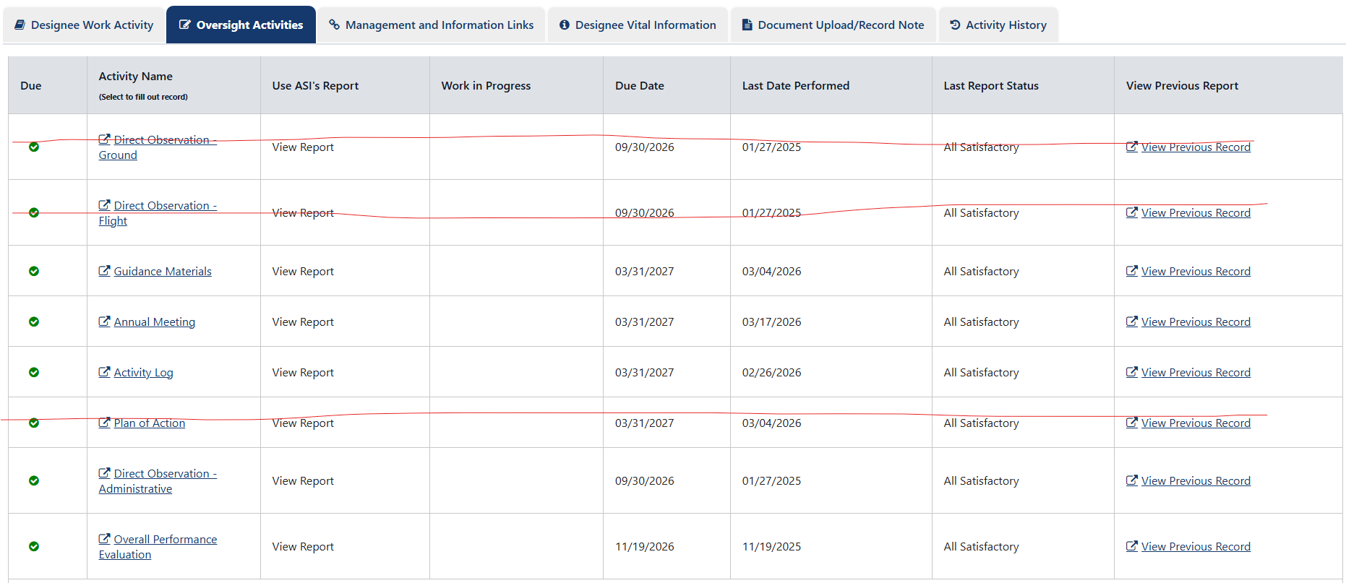

Updated below Screenshot

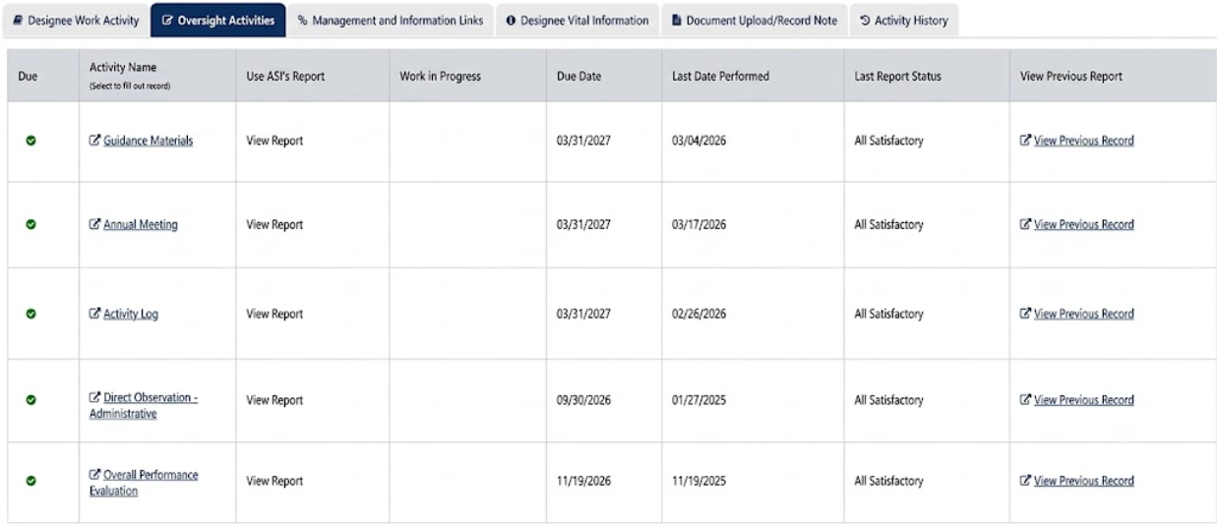
Figure 14: Oversight Activities

Table 8: Data Requirements – Oversight Activities
Scheduled Activity Name | Baseline Frequency Tracking Logic | Required Actions / Inputs | System Form Target
Guidance Materials | Recurrent automated verification checks against core libraries. | Select verification choice state checklist metrics. | Read-Only Summary view with attachment pathways.
Annual Meeting | Tracked via cyclical timestamp verification parameters. | Log dates, update location files, and enter attendee indicators. | Interactive text data entry grid formatting tables.
Activity Log | Continuous background ingestion of data tracking logs. | Automated extraction with manual validation overrides. | Tabular list matching reference tracking records.
Direct Observation - Administrative | Recurring programmatic evaluation cycle logic. | Enter alphanumeric evaluations across core field structures. | Mandatory input layout with file link support.
Overall Performance Evaluation | Annual system generation based on calendar deadlines. | Radio group tracking inputs (Satisfactory / Unsatisfactory) with justification text zones. | Consolidated system summary sub-panel layout.

From existing DPE “Oversight Activities” tab in DMS (Bottom Half of Page)
- Remove “Testing Proficiency Check”, “Interview of Recently Tested Airman”, and “SEED Inspection”

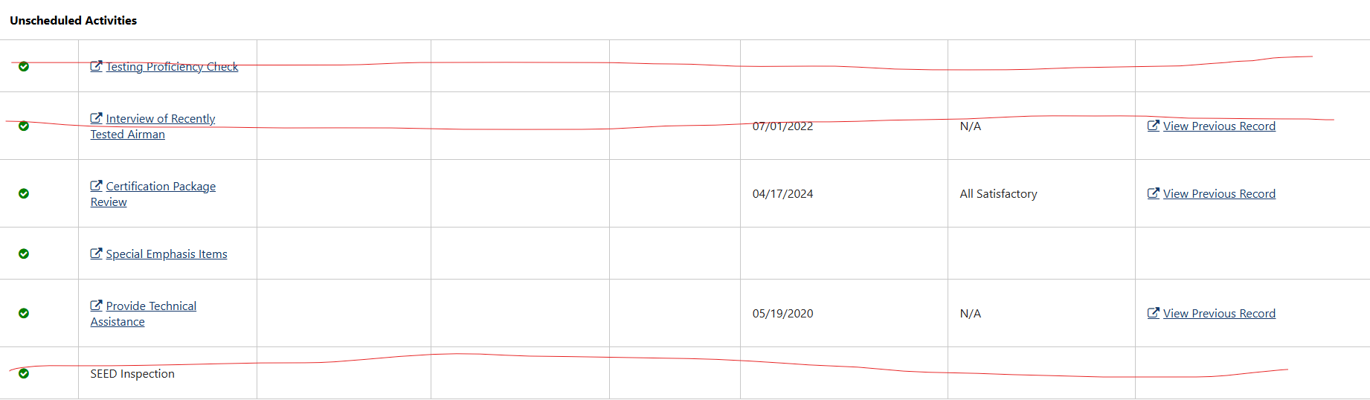

Updated below Screenshot

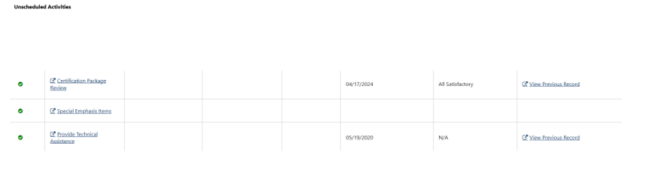
Figure 15: Oversight Activities (Unscheduled)

Table 9: Data Requirements – Oversight Activities (Unscheduled)
Unscheduled Activity Name | Baseline Trigger Mechanics | Required Actions / Inputs | System Form Target
Certification Package Review | Generated upon submission of processing files by designees. | Check error metrics, log rejection flags, or choose confirmation indicators. | Split panel presenting file attachments alongside validation forms.
Special Emphasis Items | Populated via programmatic enforcement directions from headquarters. | Log textual analysis details inside unstructured text frames. | Freeform comment area (4000 character boundaries).
Provide Technical Assistance | User-instantiated support metrics collection block. | Select categorization type, summarize interaction channels, and track processing duration. | Popup dialog workspace entry wrapper forms.

Appendices

Appendix A: Glossary
Table 10: Glossary
Term | Definition
External User | Private individuals or general public users of DMS.
Designee | Persons approved to provide certification duties and other services on behalf of the FAA.

Appendix B: Abbreviations, Acronyms, and Definitions

Table 11: Abbreviations, Acronyms, and Definitions
Abbreviation/  Acronym | Definition
FAA | Federal Aviation Administration
DMS | Designee Management System
AIR | Aircraft Certification Service
DMIR | Designated Manufacturing Inspection Representative
DAR-F | Designated Airworthiness Representative-Manufacturing
AME | Aviation Medical Examiner
DAR-T | Designated Airworthiness Representative
DER- Y | Designated Engineer Representative Company
DER-T | Designated Engineer Representative Consultant
DCTO-E | Designated Control Tower Operator Examiner
DME | Designated Mechanic Examiner
DPRE | Designated Parachute Rigger Examiner
DPE | Designated Pilot Examiner
SAE | Specialty Aircraft Examiner
Admin-PE | Administrative Pilot Examiner
Admin-PE-GEN | Administrative Pilot Examiner with General Authorizations
APD | Aircrew Program Designee
DADE | Designated Aircraft Dispatcher Examiner
TCE | Training Center Evaluator

Appendix C: Country List:
Afghanistan
Albania
Algeria
Andorra
Angola
Antigua and Barbuda
Argentina
Armenia
Australia
Austria
Azerbaijan
Bahamas
Bahrain
Bangladesh
Barbados
Belarus
Belgium
Belize
Benin
Bhutan
Bolivia
Bosnia and Herzegovina
Botswana
Brazil
Brunei Darussalam
Bulgaria
Burkina Faso
Burundi
Cambodia
Cameroon
Canada
Cape Verde
Central African Republic
Chad
Chile
China
Colombia
Comoros
Congo Dr
Cook Islands
Costa Rica
Cote D'ivoire
Croatia
Cuba
Cyprus
Czech Republic
Denmark
Djibouti
Dominica
Dominican Republic
Ecuador
Egypt
El Salvador
Equatorial Guinea
Eritrea
Estonia
Ethiopia
Fiji
Finland
France
Gabon
Gambia
Georgia
Germany
Ghana
Greece
Grenada
Guatemala
Guinea
Guinea-Bissau
Guyana
Haiti
Honduras
Hungary
Iceland
India
Indonesia
Iran
Iraq
Ireland
Israel
Italy
Jamaica
Japan
Jordan
Kazakhstan
Kenya
Kiribati
Korea (North)
Korea (South)
Kuwait
Kyrgyzstan
Laos
Latvia
Lebanon
Lesotho
Liberia
Libya
Lithuania
Luxembourg
Madagascar
Malawi
Malaysia
Maldives
Mali
Malta
Marshall Islands
Mauritania
Mauritius
Mexico
Micronesia
Moldova
Monaco
Mongolia
Montenegro
Morocco
Mozambique
Myanmar
Namibia
Nauru
Nepal
Netherlands
New Zealand
Nicaragua
Niger
Nigeria
Norway
Oman
Pakistan
Palau
Panama
Papua New Guinea
Paraguay
Peru
Philippines
Poland
Portugal
Qatar
Republic of Macedonia
Romania
Russian Federation
Rwanda
Saint Kitts And Nevis
Saint Lucia
Saint Martin
Saint Vincent and the Grenedines
Samoa
San Marino
Sao Tome and Principe
Saudi Arabia
Senegal
Serbia
Seychelles
Sierra Leone
Singapore
Slovakia
Slovenia
Solomon Islands
Somalia
South Africa
South Sudan
Spain
Sri Lanka
Sudan
Suriname
Swaziland
Sweden
Switzerland
Syria
Taiwan
Tajikistan
Tanzania
Thailand
Timor-Leste
Togo
Tonga
Trinidad and Tobago
Tunisia
Turkey
Turkmenistan
Uganda
Ukraine
United Arab Emirates
United Kingdom
United States
Uruguay
Uzbekistan
Vanuatu
Venezuela
Vietnam
Yemen
Zambia
Zimbabwe
Zaire
Western Samoa
West Indies
Wake Island
Trust Terr Pac Isl
Ryukyu Islands
Martinique
Johnston Atoll
French Polynesia
Canal Zone
Burma
British Virgin Is
Macau
Hong Kong
Cayman Islands
British West Indies
Bermuda
Aruba
Saipan
Saint Martin

Appendix D: State List
 | Alaska | AK
 | Alabama | AL
 | Arkansas | AR
 | Arizona | AZ
 | California | CA
 | Colorado | CO
 | Connecticut | CT
 | DC | DC
 | Delaware | DE
 | Florida | FL
 | Georgia | GA
 | Hawaii | HI
 | Iowa | IA
 | Idaho | ID
 | Illinois | IL
 | Indiana | IN
 | Kansas | KS
 | Kentucky | KY
 | Louisiana | LA
 | Massachusetts | MA
 | Maryland | MD
 | Maine | ME
 | Michigan | MI
 | Minnesota | MN
 | Missouri | MO
 | Mississippi | MS
 | Montana | MT
 | North Carolina | NC
 | North Dakota | ND
 | Nebraska | NE
 | New Hampshire | NH
 | New Jersey | NJ
 | New Mexico | NM
 | Nevada | NV
 | New York | NY
 | Ohio | OH
 | Oklahoma | OK
 | Oregon | OR
 | Pennsylvania | PA
 | Rhode Island | RI
 | South Carolina | SC
 | South Dakota | SD
 | Tennessee | TN
 | Texas | TX
 | Utah | UT
 | Virginia | VA
 | Vermont | VT
 | Washington | WA
 | Wisconsin | WI
 | West Virginia | WV
 | Wyoming | WY
 | N/A | N/A
 | Guam | GU
 | American Samoa | AS
 | Marshall Islands | MH
 | North Mariana Islands | MP
 | US Minor Outlying Islands | MU
 | Puerto Rico | PR
 | Virgin Islands | VI
 | AE | AE
 | AP | AP

 | Functional Requirements Document  Authorization Memorandum

FAA INFORMATION TECHNOLOGY (AIT) PROJECT MANAGEMENT CERTIFICATION
By signing below, I acknowledge that I have read, reviewed and approved the contents of this document.

________________ ________________________ _____________________
DMS AIT SIGNATURE DATE
Project Manager

________________ _________________________ _____________________
DMS AIT PM’s SIGNATURE DATE
Branch Manager

